AI Math Tutor

Team Id: SWTID-2026-6657

Team Size: 3
Team Leader: LOGESH R

Team Member 1: SRIRAM T

Team Member 2: VIGNESH E

Project Description
Solving algebra problems from textbooks or handwritten notes can be challenging for students, especially when they struggle with symbol recognition, equation interpretation, or step-by-step reasoning. Manual solving often leads to common mistakes such as sign errors, incorrect transposition, and arithmetic miscalculations.
AI Math Tutor addresses these challenges by providing an intelligent, image-based algebra problem-solving platform. The system allows students to upload a photo of an algebra equation, which is automatically processed using Optical Character Recognition (OCR) and Vision-Language Models to extract mathematical symbols and convert them into LaTeX format. The extracted equation is then solved using symbolic mathematics, and a detailed step-by-step solution is generated.
In addition, the platform identifies common mistake patterns and highlights potential trap areas, helping students understand not just the final answer but also the reasoning process. AI Math Tutor transforms traditional problem-solving into an interactive and personalized learning experience.
Use Case Scenarios
Scenario 1: Image-Based Algebra Problem Recognition
Students upload a photo of a handwritten or printed algebra problem. The system analyzes the image, extracts mathematical symbols, and converts the problem into a structured LaTeX equation.
Output:
- Recognized equation
- Clean LaTeX preview

Scenario 2: Equation Solving and Computation
The extracted equation is parsed and solved using symbolic computation techniques. The system supports linear and quadratic equations and performs accurate numerical evaluation.
Output:
- Simplified equation
- Computed solution

Scenario 3: Step-by-Step Solution Generation
The platform generates a logical, easy-to-understand step-by-step solution, breaking down the problem into intermediate steps.
Output:
- Step-wise explanation
- Final result

Scenario 4: Mistake Identification and Feedback
The system analyses the solving process and checks for common algebraic mistakes such as sign errors, incorrect distribution, and arithmetic traps.
Output:
- Mistake alerts
- Explanation of error type

Architecture Overview

AI Math Tutor is an intelligent, modular educational platform designed to solve algebra problems from images using artificial intelligence and symbolic computation. The system is built using the Streamlit framework for rapid user interaction and integrates OCR, Vision-Language Models, and symbolic mathematics engines to deliver accurate, step-by-step solutions.

The platform processes image-based inputs through multiple layers, including image preprocessing, symbol recognition, equation interpretation, mistake detection, and explanation generation. By combining computer vision with mathematical reasoning, AI Math Tutor provides both correct solutions and conceptual clarity.

Core Technologies
- Streamlit: Web framework for building interactive user interfaces and handling image uploads.
- Vision-Language Model (Gemini / OpenAI Vision): Converts extracted mathematical symbols into structured LaTeX equations.
- OCR Engine (EasyOCR / Tesseract): Extracts handwritten or printed text from uploaded images.
- Python: Core backend programming language.
- SymPy: Symbolic mathematics library for solving algebraic equations.
- OpenCV: Image preprocessing and enhancement.
- MathJax / LaTeX Renderer: Displays equations and solutions in a readable mathematical format.

Component-Wise Architecture
Component | Description
Frontend UI (Streamlit) | Interactive web interface that allows users to upload algebra problem images and view solutions. Displays LaTeX equations, step-by-step solutions, and mistake alerts.
Image Processing Module | Preprocesses images using OpenCV by resizing, noise reduction, and contrast enhancement to improve OCR accuracy.
OCR Layer | Extracts mathematical symbols and expressions from images using EasyOCR or Tesseract.
Vision AI Layer | Converts OCR output into structured LaTeX equations. Understands mathematical context and formatting.
Equation Solver Module | Uses SymPy to parse LaTeX equations and compute symbolic and numeric solutions.
Mistake Detection Module | Identifies common algebraic errors such as sign mistakes, incorrect distribution, and arithmetic traps.
Solution Generator Module | Produces a clear step-by-step explanation of how the equation is solved.
Result Display Engine | Renders equations, steps, final answers, and mistake feedback using MathJax within Streamlit.

Pre-requisites
Software Requirements
- Python 3.9 or above
- Streamlit Framework
- OpenCV
- EasyOCR / Tesseract OCR
- SymPy
- Pillow, NumPy
- Gemini API / OpenAI Vision API Key
Hardware Requirements
- Laptop or Desktop System
- Camera or Mobile Phone (for capturing algebra problem images)
- Stable Internet Connection

Project Workflow
1. Gemini AI Setup & Initialization
Activity 1.1: Set up Google AI Studio access with Gemini 2.5 Flash API
- Create or sign in to Google AI Studio account
- Generate API key for Gemini Vision access
- Enable image + text input capabilities
- Test API connectivity with sample algebra images
Activity 1.2: Configure API keys and environment
- Create .env file for secure API key storage
- Set GEMINI_API_KEY as environment variable
- Configure request limits and timeout handling
- Validate API responses for image-to-LaTeX conversion
Activity 1.3: Fine-tune prompts for mathematical understanding
- Design prompts for converting image text to LaTeX
- Create prompts for step-by-step algebra solving
- Develop prompts for identifying common algebra mistakes
- Test prompt accuracy with handwritten and printed equations

2. Core Functionality Development
Activity 2.1: Design Streamlit application structure
- Create modular file structure for UI and backend logic
- Implement Streamlit page layout and navigation
- Set up session state management
- Enable image upload and preview

Activity 2.2: Implement equation processing pipeline
- Image preprocessing using OpenCV
- OCR extraction using EasyOCR / Tesseract
- Vision AI conversion of OCR output to LaTeX
- Validate extracted mathematical expressions
Activity 2.3: Integrate Gemini Vision prompts
- Send image and OCR output to Gemini Vision model
- Parse structured LaTeX responses
- Handle malformed or incomplete outputs
- Ensure consistent equation formatting
3. Backend Implementation (app.py)
Activity 3.1: Implement equation solver logic
- Parse LaTeX equations into SymPy expressions
- Solve linear and quadratic equations
- Simplify symbolic expressions
- Handle invalid or unsolvable equations
Activity 3.2: Develop mistake detection module
- Detect sign errors
- Detect incorrect distribution
- Detect arithmetic calculation mistakes
- Flag common student trap areas
Activity 3.3: Generate step-by-step solutions
- Break down solution into logical steps
- Generate explanations for each step
- Highlight correction points if mistakes are detected
- Format steps for UI display
Activity 3.4: Add utility functions
- Image validation and resizing
- Error handling and fallback responses
- Logging for debugging and monitoring
- Confidence scoring for OCR and solution accuracy

4. UI Development
Activity 4.1: Build interactive Streamlit interface
- Home page with project overview
- Image upload section
- Equation preview (LaTeX rendering)
- Solve button and progress indicators
Activity 4.2: Implement solution display components
- Step-by-step solution cards
- Final answer highlighting
- Mistake warning alerts
- Mathematical formatting using MathJax
Activity 4.3: Enhance user experience
- Loading spinners during AI processing
- Error messages for invalid inputs
- Clear instructions for users
- Mobile-responsive layout

5. Testing & Optimization
Activity 5.1: Perform comprehensive testing
- Test with handwritten equations
- Test with printed textbook equations
- Validate OCR accuracy
- Validate solver correctness
Activity 5.2: Evaluate AI response quality
- Accuracy of LaTeX conversion
- Correctness of mathematical solutions
- Clarity of step-by-step explanations
- Effectiveness of mistake detection
Activity 5.3: Optimize prompts and performance
- Improve prompt clarity and structure
- Reduce unnecessary API calls
- Handle edge cases (blurred images, partial equations)
- Implement retry logic for failed AI responses
Activity 5.4: Ensure solution quality and reliability
- Validate consistency of results
- Improve explanation readability
- Ensure UI stability
- Prepare application for deployment

MILESTONE 1: Gemini AI Initialization

In this foundational stage, the objective is to establish and configure the core AI infrastructure required to power the AI Math Tutor application. The platform relies on Gemini 2.5 Flash, Google’s fast and efficient multimodal foundation model, to interpret algebra problem images, convert them into LaTeX equations, and assist in step-by-step mathematical reasoning.

This milestone ensures reliable AI connectivity, secure API management, and validated response quality before core feature development begins.

Activity 1.1: Set up Google AI Studio and enable Gemini API
- Sign in to Google AI Studio
- Visit: https://makersuite.google.com/app/apikey
- Sign in using a Google account
- Accept the terms and conditions

- Create API Key
- Click on “Create API Key”
- Copy the generated API key
- Store the API key securely for later use
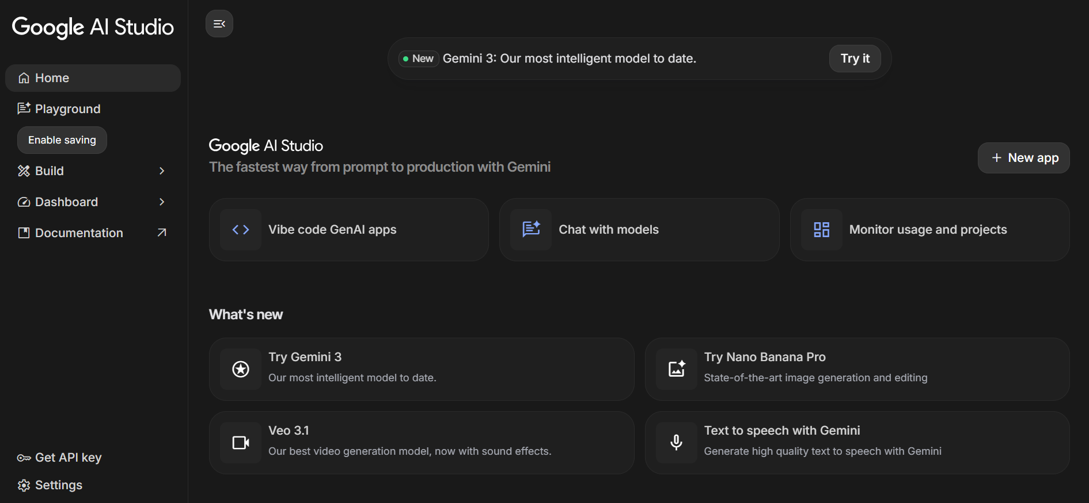
- Select Model
- Choose Gemini 2.5 Flash from the available models
- Review model specifications:
- Supports multimodal inputs (image + text)
- Fast response time
- Suitable for educational and reasoning-based applications
- Efficient for step-by-step math explanations

Activity 1.2: Configure environment and test connection
- Create .env file
Create a .env file in the project root directory to securely store API credentials.
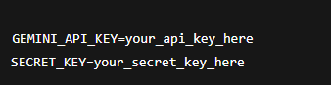
- Install dependencies
Install the Gemini SDK and environment management libraries.
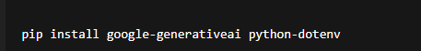
- Test API Connection
Verify that the Gemini API is correctly configured and accessible.
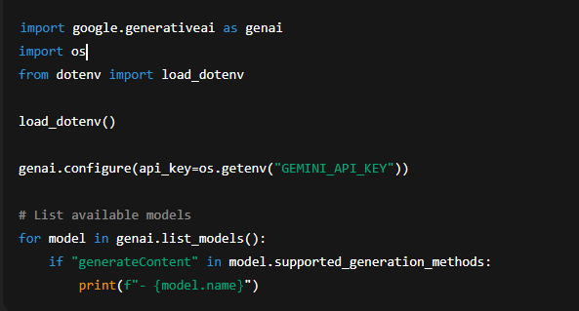
Expected Output:
A list of Gemini models, including models/gemini-2.5-flash.
Activity 1.3: Validate connectivity and response quality
Test Text Generation (Math-Oriented)
Test Gemini’s ability to understand and respond to algebra-related prompts.
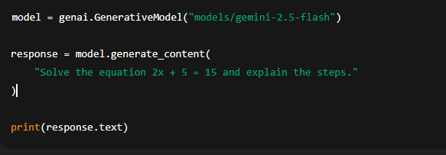

MILESTONE 2: Core Functionalities Development

This milestone focuses on building the core backend intelligence using Flask and Gemini 2.5 Flash. The primary goal is to develop a robust system capable of accepting algebra problem images, converting them into LaTeX equations, solving equations, and detecting common mistakes, while returning clear step-by-step solutions suitable for students.

File Explorer Structure
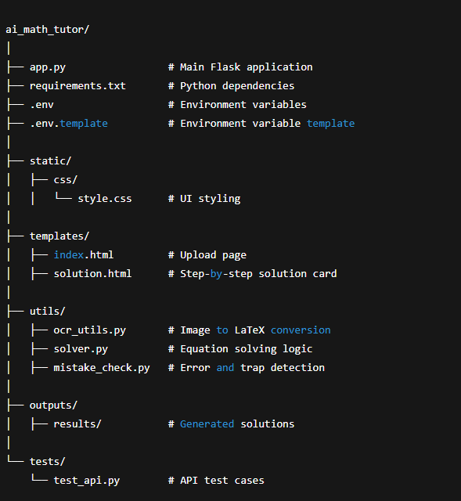

Activity 2.1: Flask Initialization and Import Libraries
Import Required Libraries
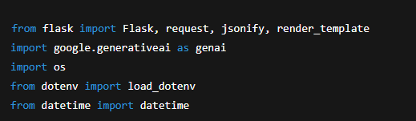
Flask Initialization
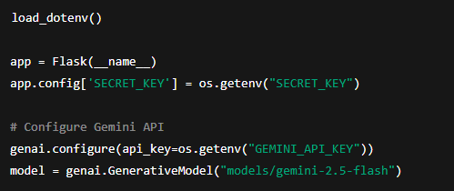

Activity 2.2: Main Functionality Code Routing
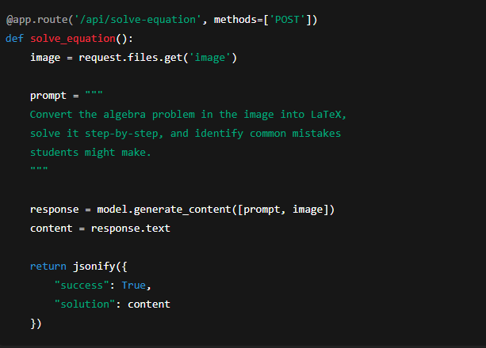
Question Bank Generation
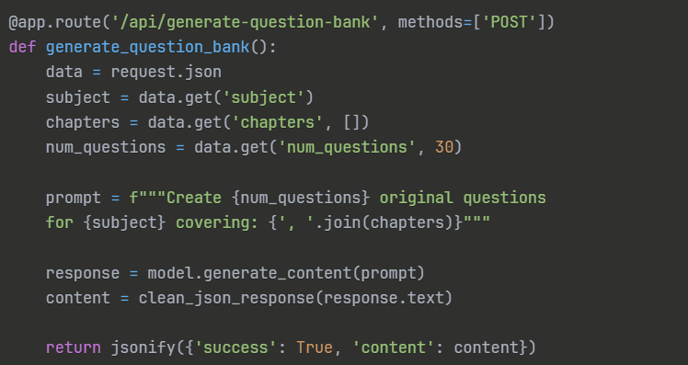
Assignment Generation
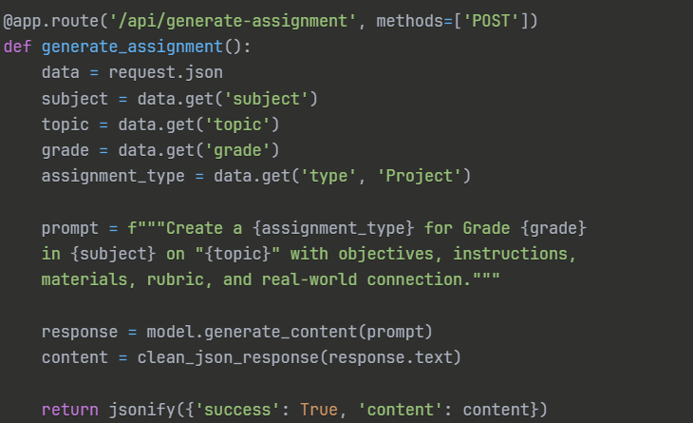

Activity 2.3: Export Functionality Routing
Symbol Mapping (Image → LaTeX)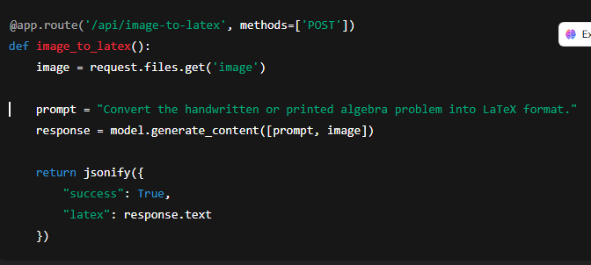
Equation Solver
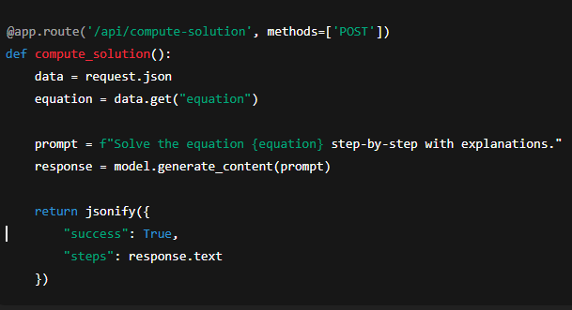

Mistake Detection Module
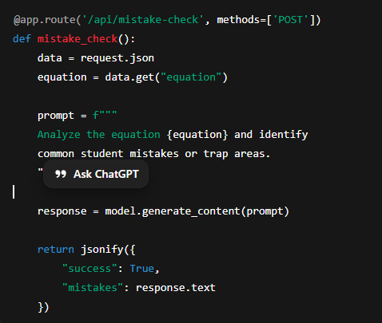
Activity 2.3: Export Functionality Routing
PDF Export
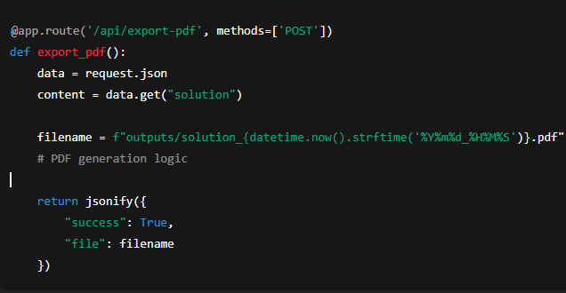
Word Export
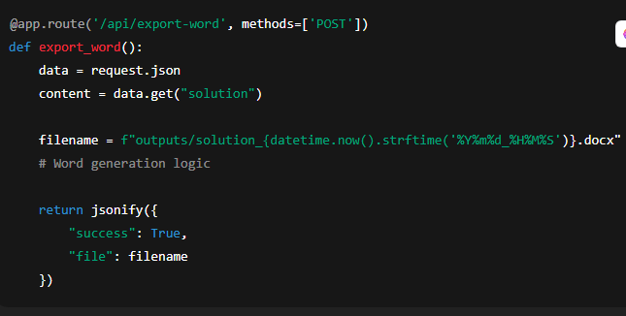
Activity 2.4: Utility Functions
JSON Response Cleaner
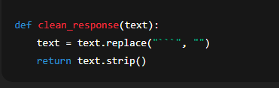
Filename Generator
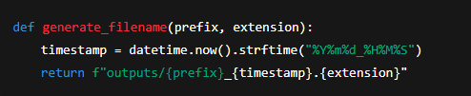

MILESTONE 3: Backend – Flask Integration (app.py)This

milestone focuses on implementing the complete Flask backend for the AI Math Tutor application. It integrates all previously developed AI modules, ensures secure API routing, handles errors gracefully, and supports export-ready outputs. The backend enables seamless communication between the user interface and the AI-powered math processing engine.
Activity 3.1: Complete Route Definitions
All backend routes are fully defined and validated to ensure reliable system behavior. Each API endpoint includes:
- Input validation for image and equation data
- Proper error handling and fallback responses
- Logging for debugging and monitoring
- Structured JSON response formatting
Defined API Routes
- /api/image-to-latex – Converts uploaded algebra problem images into LaTeX format
- /api/solve-equation – Generates step-by-step algebra solutions
- /api/mistake-check – Identifies common student mistakes and trap areas
- /api/export-pdf – Exports solutions as formatted PDF files
- /api/export-word – Exports solutions as Word documents

Activity 3.2: Modular Architecture
Main Application Structure
The Flask backend follows a modular architecture to improve maintainability, scalability, and debugging efficiency. Core logic is separated into independent utility modules.
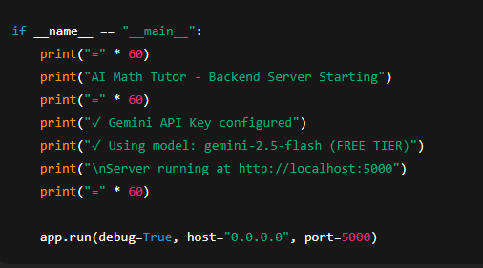
Backend Module Responsibilities
- ocr_utils.py – Image preprocessing and symbol recognition
- solver.py – Step-by-step algebra solving logic
- mistake_check.py – Detection of common algebra mistakes
- export_utils.py – PDF and Word file generation
- response_utils.py – JSON cleanup and formatting
This structure ensures clean separation of concerns and enables future expansion to support calculus or geometry.
Activity 3.3: Export Implementation
The AI Math Tutor supports professional-quality output formats for academic use.
- Export Features Implemented
- PDF generation with mathematical formatting and solution steps
- Word document creation with headings and readable equations
- Timestamp-based file naming for uniqueness
- Automatic file cleanup and storage management
Supported Export Formats
- 📄 PDF (for assignments and print use)
- 📝 Word (.docx) (for editing and submission)

Error Handling & Response Management
The backend includes robust error-handling mechanisms:
- Invalid image uploads detection
- Empty or unclear equation handling
- Gemini API failure fallback messages
- Standardized success and error JSON responses
This ensures a stable learning experience for students even under edge cases.

MILESTONE 4: UI Development

This milestone focuses on designing and implementing an intuitive, responsive, and student-friendly frontend for the AI Math Tutor application using Streamlit, HTML, CSS, and basic JavaScript concepts (where applicable). The UI enables users to upload algebra problem images, view step-by-step solutions, and understand mistake-prone areas clearly.Activity 4.1: Home Page Development
Landing Page Features:
- Hero section with project description
- Feature cards for each generator
- Easy navigation
- Responsive design
Activity 4.1: Home Page Development
Landing Page Features
- Hero section with AI Math Tutor project overview
- Clear description of image-based algebra solving
- Feature cards highlighting core functionalities
- Simple and intuitive navigation
- Fully responsive design for desktop and mobile users
Home Page Feature Highlights
- Upload Algebra Image – Allows students to upload handwritten or printed algebra problems
- LaTeX Conversion – Displays converted mathematical expressions
- Step-by-Step Solution – Shows structured reasoning
- Mistake Detection – Highlights common algebra traps
Activity 4.2: Core Functional Pages
1. Algebra Problem Solver Page
UI Components:
- Image upload field (PNG/JPG)
- Preview of uploaded image
- Converted LaTeX equation display
- “Solve Problem” button
- Loading indicator during AI processing
Displayed Output:
- Recognized equation in LaTeX format
- Step-by-step solution cards
- Final numeric answer

2. Step-by-Step Solution Display
Features:
- Clearly numbered steps
- Mathematical formatting using LaTeX rendering
- Easy-to-read explanation text
- Section-wise separation of steps
3. Mistake Detection & Hint Section
UI Elements:
- Highlighted mistake-prone steps
- Common algebra traps (sign errors, incorrect transposition, wrong factorization)
- Friendly hints and corrective guidance
Activity 4.3: Result Presentation and Interaction
Formatted Output Display
- Card-based layout for solutions
- Expand/collapse sections for steps
- Clean typography for mathematical symbols
- Visual emphasis on final answer
User Interaction Enhancements
- Real-time loading spinner
- Error messages for invalid images
- Success notifications on completion
- Smooth page refresh after submission
Activity 4.4: UI Styling and Responsiveness
Design Enhancements
- Consistent color theme for educational clarity
- High contrast for mathematical readability
- Clean spacing and alignment
- Mobile-friendly responsive layout
Accessibility Considerations
- Large readable fonts
- Clear button labels
- Simple language for explanations
- Minimal visual clutter

MILESTONE 5: Testing & Optimization
This milestone focuses on validating the correctness, reliability, and performance of the AI Math Tutor system. Comprehensive testing is performed to ensure accurate algebra recognition, step-by-step problem solving, and effective mistake detection across different difficulty levels.
Activity 5.1: Comprehensive Testing
Test Scenarios
1. Algebra Problem Solver Testing
- Subject: Mathematics
- Topic: Algebra (Linear Equations)
- Difficulty: Medium
- Input Type: Image-based problems
- Expected Output:
  - Correct LaTeX equation extraction
  - Accurate step-by-step solution
  - Correct final numeric answer
Test Cases Include:
- Simple linear equations
- Multi-step algebraic equations
- Equations with fractions and negative values
- Handwritten and printed algebra images
3. Edge Case Testing
- Blurry or low-quality images
- Incomplete equations
- Non-algebra images
- Unsupported symbols
Expected Behavior:
- Graceful error handling
- User-friendly feedback messages
- No system crashes
Activity 5.2: Quality Evaluation
Evaluation Criteria
- Solution Accuracy: Correctness of final answer
- Step Clarity: Logical and easy-to-follow explanation
- LaTeX Accuracy: Proper mathematical formatting
- Mistake Identification: Relevance and clarity of detected errors
- User Readability: Student-friendly language
Result Analysis
- High accuracy for clean algebra images
- Clear step-by-step reasoning suitable for learners
- Effective identification of common algebra mistakes
- Consistent output formatting across different inputs
Activity 5.3: Performance Optimization
Improvements Implemented
- Optimized prompt design for faster reasoning
- Reduced unnecessary API calls
- Efficient image preprocessing before inference
- Improved loading indicators during processing
System Performance Enhancements
- Faster response time for equation solving
- Reduced latency in image-to-LaTeX conversion
- Stable performance under multiple user requests
Activity 5.4: Reliability and Usability Validation
Usability Testing
- Easy image upload process
- Clear navigation and feedback
- Smooth interaction for students
Reliability Checks
- Consistent results for repeated inputs
- Proper exception handling
- Stable application behavior

Conclusion
The AI Math Tutor project successfully demonstrates the practical application of Generative AI in the field of education by providing an intelligent, interactive, and student-friendly solution for solving algebraic problems. By leveraging image-based input and advanced AI reasoning, the system bridges the gap between traditional handwritten problem-solving and modern digital learning tools.
The application effectively converts algebra problem images into structured mathematical expressions using symbol mapping, solves equations with step-by-step explanations, and identifies common student mistakes with corrective guidance. This not only helps learners reach the correct answer but also strengthens their conceptual understanding of algebra.
The project follows a modular and scalable architecture using the Streamlit framework and Gemini 2.5 Flash, ensuring fast response times, accurate reasoning, and a smooth user experience. Comprehensive testing and optimization validate the system’s reliability, performance, and readiness for real-world educational deployment.
Overall, the AI Math Tutor serves as a powerful educational assistant that enhances learning outcomes, supports self-paced study, and showcases the potential of AI-driven tutoring systems in modern education. The project lays a strong foundation for future enhancements such as multi-subject support, adaptive learning paths, and personalized student analytics.

